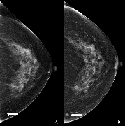

Dense Layer

DenseNet201 CC View Pathway

Output

Average Pooling

Concantenation

DenseNet201 MLO View Pathway

